Pharmaceutical Product Data Analysis for Price Optimization & Drug Comparison
Table of Contents
- Abstract
- Introduction
  - 2.1 Background
  - 2.2 Problem Statement
  - 2.3 Objectives
- Dataset Collection and Description
  - 3.1 Dataset Source
  - 3.2 Dataset Overview
  - 3.3 Dataset Columns
  - 3.4 Sample Dataset Records
- Technologies and Tools Used
- Data Understanding
  - 5.1 Understanding Dataset Structure
  - 5.2 Data Types
  - 5.3 Numerical and Categorical Columns
  - 5.4 Statistical Analysis
  - 5.5 Choosing Visualization Techniques
- Data Preprocessing
  - 6.1 Handling Missing Values
  - 6.2 Outlier Detection and Removal
- Feature Engineering and Feature Extraction
  - 7.1 Medicine Form Extraction
  - 7.2 Strength Extraction
  - 7.3 Label Encoding
- Exploratory Data Analysis (EDA)
  - 8.1 Univariate Analysis
  - 8.2 Bivariate Analysis
  - 8.3 Multivariate Analysis
- Final Conclusions from Visualizations
- Challenges Faced
- Future Scope
- References
- GitHub Repository

1. Abstract
The pharmaceutical industry generates a massive amount of medicine-related data involving drug pricing, formulations, pack sizes, compositions, and manufacturers. Understanding these relationships is essential for healthcare analytics, pharmaceutical retail management, market segmentation, and price optimization.
This project focuses on Exploratory Data Analysis (EDA) of pharmaceutical product data collected from OpenDataBay. The dataset contains over 2.5 lakh pharmaceutical products with information about medicine names, prices, compositions, pack sizes, manufacturers, and medicine categories.
The analysis was performed using Python libraries such as Pandas, NumPy, Matplotlib, and Seaborn. Multiple preprocessing techniques including missing value handling, feature extraction, outlier detection, and visualization were applied to analyze pricing behavior and pharmaceutical market trends.
Through univariate, bivariate, and multivariate analysis, the project identified major pricing patterns across medicine forms, manufacturers, strengths, and packaging types. The analysis revealed that tablets dominate the affordable medicine market, while injections contribute significantly to premium pricing and outliers.
The findings from this project can support pharmaceutical price optimization, drug comparison systems, healthcare analytics, and pharmaceutical market segmentation.

2. Introduction
2.1 Background
The pharmaceutical industry plays an important role in healthcare by manufacturing and distributing medicines for different diseases and treatments. Pharmaceutical products vary based on:
- Medicine form
- Drug composition
- Dosage strength
- Packaging size
- Manufacturer
- Therapeutic category
These factors create significant variations in pharmaceutical pricing.
With the availability of healthcare datasets, data analytics and visualization techniques can be used to identify hidden trends, pricing patterns, and medicine distribution behavior. Exploratory Data Analysis (EDA) helps understand pharmaceutical product characteristics and provides insights into market behavior.
2.2 Problem Statement
The pharmaceutical market contains medicines ranging from low-cost generic tablets to extremely expensive specialty injections. Understanding these pricing differences is important for:
- Drug comparison
- Healthcare affordability analysis
- Pharmaceutical market segmentation
- Price optimization
- Manufacturer-level pricing analysis
- Product positioning
This project aims to analyze pharmaceutical product data and identify how different factors influence medicine pricing.

2.3 Objectives
The major objectives of this project are:
- To analyze pharmaceutical pricing behavior.
- To identify the relationship between medicine form and price.
- To compare pharmaceutical manufacturers based on pricing.
- To analyze pack size influence on price.
- To identify high-cost and low-cost medicines.
- To study the impact of composition strength on pricing.
- To perform univariate, bivariate, and multivariate analysis.
- To identify outliers and pharmaceutical market trends.

3. Dataset Collection and Description
3.1 Dataset Source
- Source: OpenDataBay.com
- Dataset Name: Indian Medicine Dataset
- File Format: CSV

3.2 Dataset Overview
Attribute | Details
Total Rows | 253,973
Total Columns | 9
Dataset Type | Structured Tabular Data
Domain | Pharmaceutical Product Analytics

3.3 Dataset Columns
Column Name | Description
id | Unique identifier
name | Medicine name
price(₹) | Medicine price
Is_discontinued | Whether the medicine is discontinued
manufacturer_name | Manufacturing company
type | Allopathy / Non-allopathy
pack_size_label | Packaging information
short_composition1 | Primary active ingredient
short_composition2 | Secondary active ingredient

3.4 Sample Dataset Records
Medicine Name | Price | Manufacturer | Pack Size | Composition
Augmentin 625 Duo Tablet | ₹223.42 | GlaxoSmithKline Pharmaceuticals Ltd | Strip of 10 tablets | Amoxycillin + Clavulanic Acid
Azithral 500 Tablet | ₹132.36 | Alembic Pharmaceuticals Ltd | Strip of 5 tablets | Azithromycin
Ascoril LS Syrup | ₹118.00 | Glenmark Pharmaceuticals Ltd | Bottle of 100 ml Syrup | Ambroxol + Levosalbutamol
Allegra 120 Tablet | ₹218.81 | Sanofi India Ltd | Strip of 10 tablets | Fexofenadine

4. Technologies and Tools Used
Technology | Purpose
Python | Programming language
Pandas | Data preprocessing
NumPy | Numerical operations
Matplotlib | Data visualization
Seaborn | Statistical plotting
Scikit-learn | Encoding and preprocessing
Jupyter Notebook | Development environment

5. Data Understanding
5.1 Understanding Dataset Structure
Before performing analysis, understanding the dataset structure is essential.
df.info()
Used to understand:
- Number of rows and columns
- Data types
- Missing values
- Column information
Code
df.info()

df.describe()
Used to analyze numerical columns.
Provides:
- Mean
- Median
- Standard deviation
- Minimum value
- Maximum value
- Quartiles
Code
df.describe()

5.2 Data Types
Numerical Feature
- price(₹)
Categorical Features
- name
- manufacturer_name
- type
- pack_size_label
- short_composition1
- short_composition2
5.3 Numerical and Categorical Columns
Numerical Columns
Numerical columns contain measurable values.
Example:
- price(₹)
Categorical Columns
Categorical columns contain labels or categories.
Examples:
- manufacturer_name
- pack_size_label
- medicine name
- composition columns
5.4 Statistical Analysis
Initial Statistics of Price Column
Metric | Value
Minimum Price | ₹0
Maximum Price | ₹4,36,000
Mean Price | ₹270
Median Price | ₹79
Distribution Type | Right-Skewed
Interpretation
- Most medicines fall under affordable pricing.
- A few medicines create extreme outliers.
- Mean price is highly affected by injectio

5.5 Choosing Visualization Techniques
Different visualizations are used depending on the data type.

Data Type | Visualization | Purpose
Numerical Data | Histogram | Distribution analysis
Numerical Data | Boxplot | Outlier detection
Numerical Data | Violin Plot | Density and spread
Categorical Data | Count Plot | Frequency analysis
Categorical Data | Bar Plot | Category comparison
Categorical Data | Pie Chart | Percentage distribution
Mixed Data | GroupBy + Barplot | Relationship analysis
Multiple Features | Heatmap | Correlation analysis

6. Data Preprocessing
6.1 Handling Missing Values
The short_composition2 column contained many missing values because several medicines only contained one active ingredient.
Code
df['short_composition2'] = df['short_composition2'].fillna("None")
Result
- Missing values were handled successfully.
- Dataset consistency improved.
- Analysis became easier.
6.2 Outlier Detection and Removal
The medicine price column contained extremely large outliers caused mainly by specialty injections.
Why Remove Outliers?
Outliers:
- Distort visualizations
- Affect average values
- Increase skewness
- Reduce analysis clarity
IQR Method
Code
Q1 = df['price(₹)'].quantile(0.25)
Q3 = df['price(₹)'].quantile(0.75)
IQR = Q3 - Q1

lower_limit = Q1 - 1.5 * IQR
upper_limit = Q3 + 1.5 * IQR

df = df[(df['price(₹)'] >= lower_limit) &
(df['price(₹)'] <= upper_limit)]
Observations
- Most outliers belonged to injections.
- Outliers were valid medicines.
- Cleaned data improved visualization clarity.

7. Feature Engineering and Feature Extraction
7.1 Medicine Form Extraction
Medicine forms such as:
- Tablets
- Syrups
- Creams
- Suspensions
- Injections
were extracted from medicine names and pack size labels.
Purpose
This enabled:
- Form-wise analysis
- Form-wise visualization
- Average price comparison
- Percentage distribution analysis

7.2 Strength Extraction
Strengths such as:
- 500mg
- 10mg
- 25mg
- 100ml
were extracted from composition columns.
Purpose
- Strength vs price analysis
- Dosage comparison
- Correlation analysis
7.3 Label Encoding
Categorical features were converted into numerical format using Label Encoding.
Purpose
- Correlation analysis
- Heatmap generation
- Multivariate analysis

8. Exploratory Data Analysis (EDA)
8.1 Univariate Analysis
Univariate analysis studies a single variable individually.

8.1.1 Histogram of Medicine Prices
Why Histogram?
Histograms are used for numerical columns to analyze:
- Distribution
- Frequency
- Density
- Skewness
Code
df['price(₹)'].hist()
plt.xlabel("Frequency")
plt.ylabel("Medicine Prices")
plt.title("The Frequency of the Medicine Prices")
plt.show()
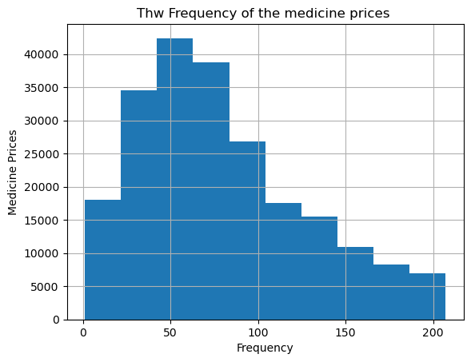
Observations
- Most medicines fall between ₹50–₹200.
- Distribution is highly right-skewed.
- Few medicines are extremely expensive.
Conclusion
The pharmaceutical market mainly consists of affordable medicines while specialty medicines form a small but expensive category.

8.1.2 Top 35 Most Common Values
Why Bar Plot?
Bar plots are used for categorical columns to compare category frequencies.
Columns Analyzed
- Medicine names
- Manufacturer names
- Pack size labels
- short_composition1
- short_composition2
Code
df[col].value_counts().head(35).plot(kind='bar', figsize=(10,5))
plt.title(f"Top 35 Most Common Values of {col}")
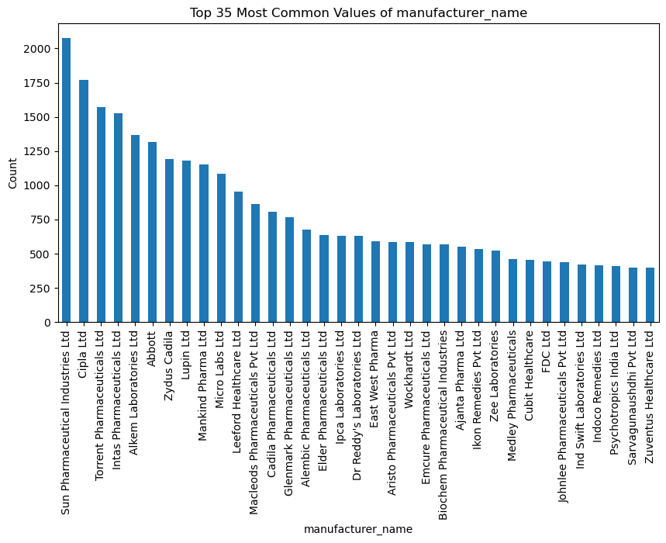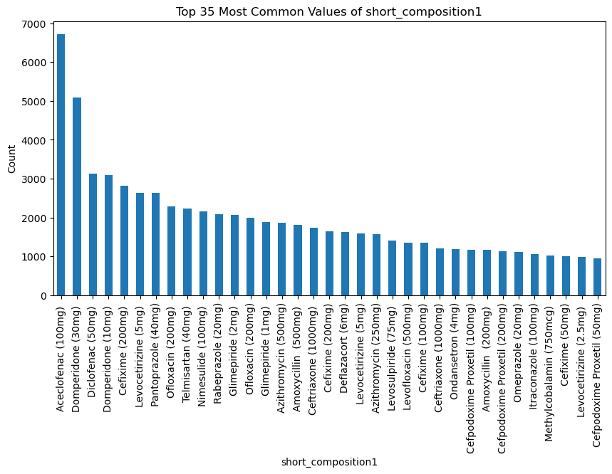
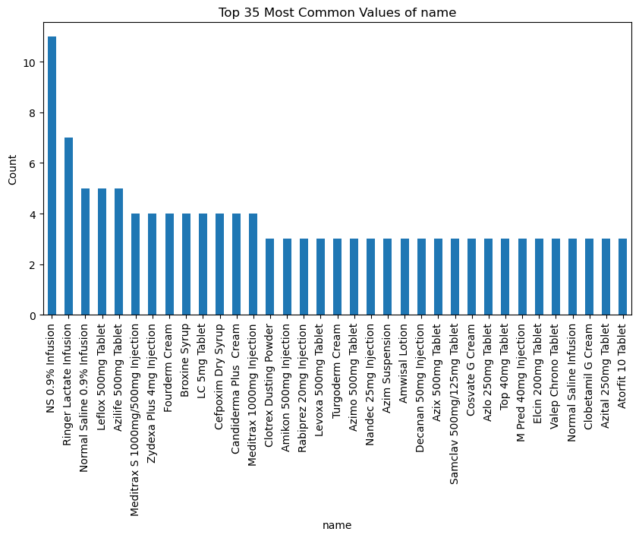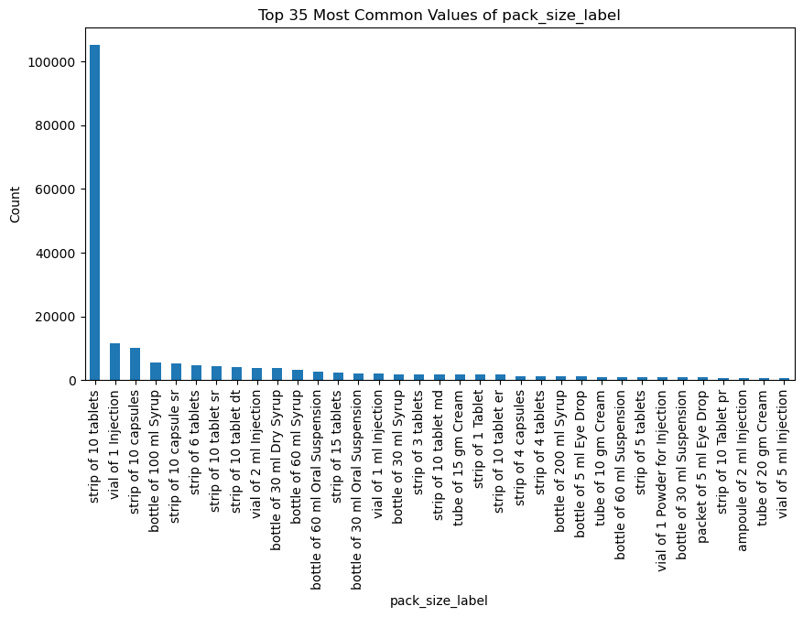

Observations
- Generic medicines dominated the dataset.
- Some manufacturers appeared repeatedly.
- Tablet-related pack sizes were highly common.
Conclusion
The Indian pharmaceutical market is dominated by generic tablet medicines.

8.1.3 Least 35 Common Values
Code
df[col].value_counts().tail(35).plot(kind='bar', figsize=(10,5))
plt.title(f"Least 35 Most Common Values of {col}")
Observations
- Rare medicines appeared in smaller quantities.
- Specialty products had lower frequency.
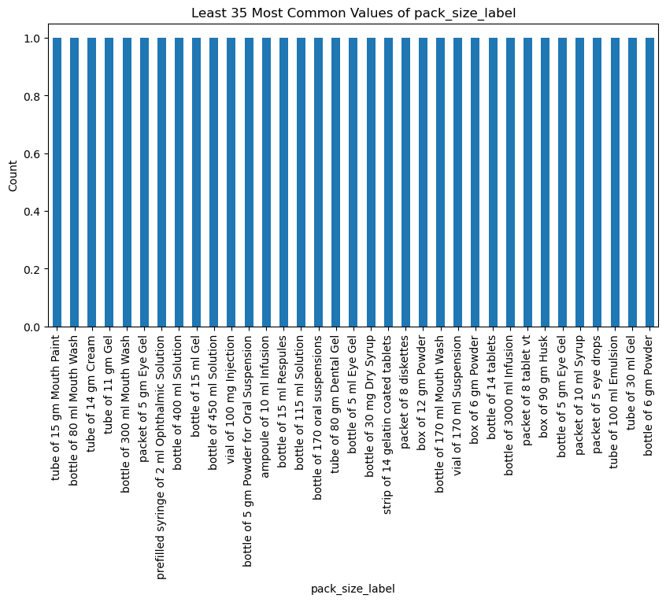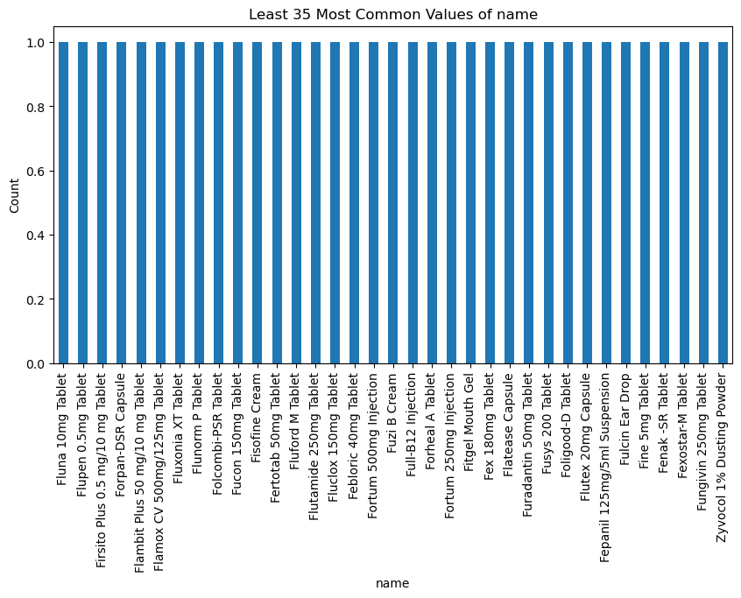
Conclusion
Low-frequency medicines belong mainly to specialized therapeutic categories.

8.1.4 Pie Chart Analysis
Why Pie Chart?
Pie charts show percentage contribution of categories.
Code
plt.pie(counts, labels=names, autopct='%1.1f%%', startangle=90)
Observations
- Tablets occupied the largest percentage.
- Syrups and suspensions occupied moderate shares.
- Injections formed a smaller portion.
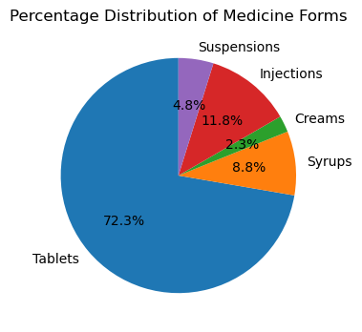
Conclusion
Tablet manufacturing dominates the pharmaceutical market.

8.1.5 Count of Medicine Forms
Code
counts = [len(data) for data in des_df]
plt.figure(figsize=(10,6))
plt.bar(names, counts)
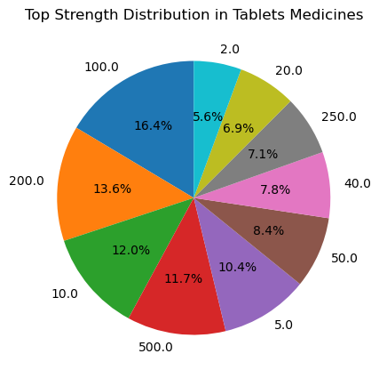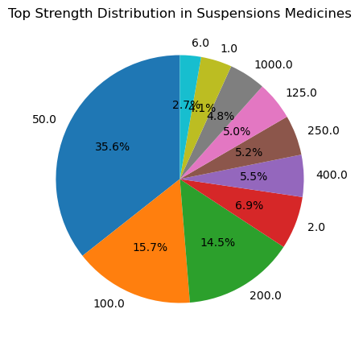
Observations
- Tablets had the highest count.
- Injections had lower count but higher prices.
Conclusion
Quantity distribution and pricing distribution differ significantly.

8.2 Bivariate Analysis
Bivariate analysis studies relationships between two variables.

8.2.1 Average Price by Manufacturer
Code
df.groupby('manufacturer_name')['price(₹)'].mean().sort_values().tail(35).plot(kind='bar')
Observations
- Envian Life Science Pvt Ltd
- Servier India Private Ltd
- Aquinnove Pharmaceutical
- Adalia Pharmaceuticals LLP
- Citade Fine Pharma
- Devburb Lifescienc
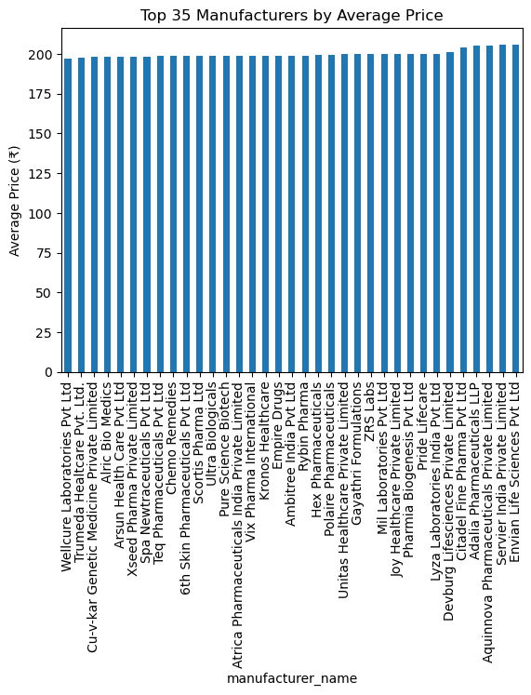
Conclusion
Premium manufacturers focus more on specialty medicines.

8.2.2 Lowest Average Price Manufacturers
Code
df.groupby('manufacturer_name')['price(₹)'].mean().sort_values().head(35).plot(kind='bar')
Observations
- Semuns Laboratories
- Sunrise International labs
- Amaze Lifestyle Products
- Neutec Healthcare
- Domination Lab Ltd
showed lower average prices.
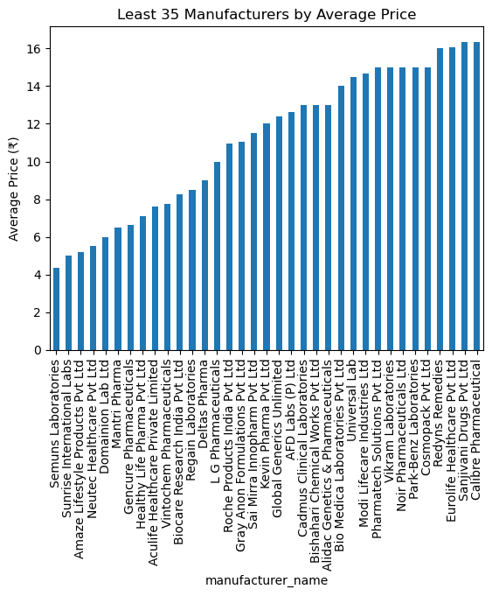
Conclusion
Generic manufacturers dominate affordable medicine production.

8.2.3 Statistical Description by Medicine Form
Code
names = ['Tablets', 'Syrups', 'Creams', 'Injections', 'Suspensions']

for i in range(len(des_df)):
print(f"--- Description for {names[i]} ---")
print(des_df[i]['price(₹)'].describe())
--- Description for Tablets ---
count 135788.000000
mean 80.313466
std 48.640499
min 1.050000
25% 44.000000
50% 70.000000
75% 110.000000
max 207.120000
Name: price(₹), dtype: float64

--- Description for Syrups ---
count 16545.000000
mean 67.400663
std 29.714416
min 2.500000
25% 47.300000
50% 65.000000
75% 82.000000
max 206.800000
Name: price(₹), dtype: float64

--- Description for Creams ---
count 4240.000000
mean 93.833285
std 48.839893
min 2.500000
25% 55.000000
50% 85.000000
75% 130.000000
max 207.000000
Name: price(₹), dtype: float64

--- Description for Injections ---
count 22223.000000
mean 73.835536
std 49.743703
min 1.250000
25% 33.000000
50% 62.000000
75% 110.000000
max 207.000000
Name: price(₹), dtype: float64
--- Description for Suspensions ---
count 9031.000000
mean 60.521560
std 36.003839
min 3.000000
25% 36.000000
50% 50.640000
75% 74.000000
max 207.000000
Name: price(₹), dtype: float64
Observations
- Tablets showed lower mean prices.
- Injections showed very high maximum values.
- Creams and suspensions showed moderate variation.
Conclusion
Medicine form strongly affects pharmaceutical pricing.

8.2.4 Average Price by Medicine Form
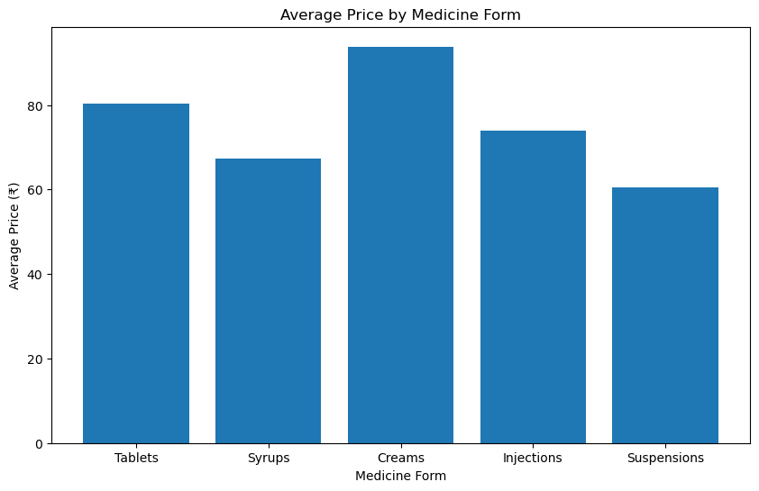
Code
for data in des_df:
avg_prices.append(data['price(₹)'].mean())

plt.figure(figsize=(10,6))
plt.bar(names, avg_prices)
Observations
- Injections had the highest average price.
- Tablets had the lowest average price.
Conclusion
Injectables dominate premium pharmaceutical pricing.

8.2.5 Price Distribution by Medicine Form
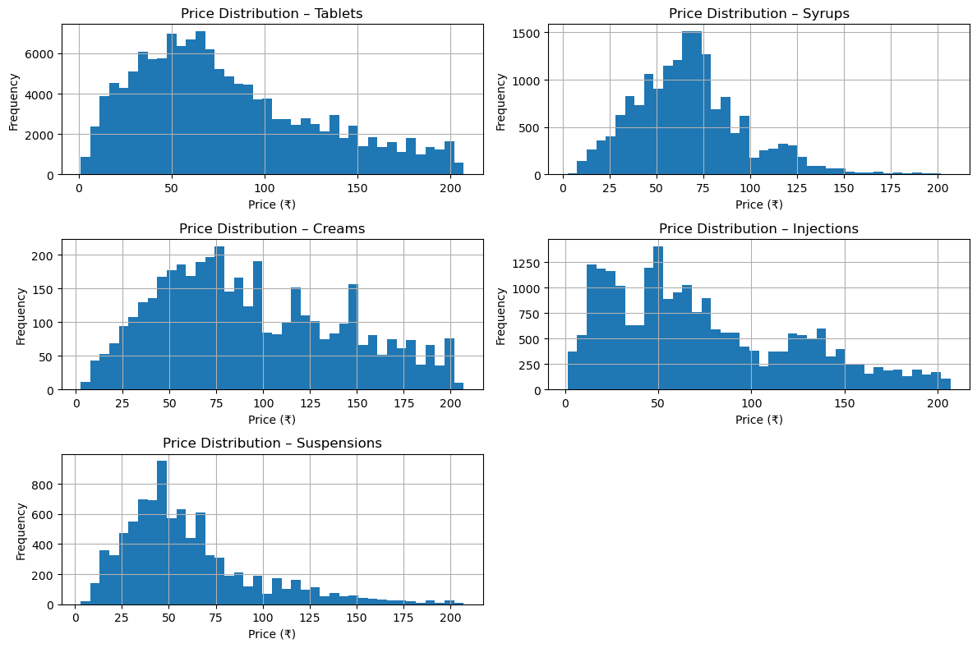
Code
for i in range(len(des_df)):
plt.subplot(3,2,i+1)
des_df[i]['price(₹)'].hist(bins=40)
Observations
Tablets
- Strong cluster below ₹200.
- Stable pricing.
Syrups
- Predictable pricing range.
Creams
- Moderate price skew.
Suspensions
- More variation than syrups.
Injections
- Highest spread and strongest outliers.
Conclusion
Medicine form type is one of the strongest price determinants
8.2.6 Top 35 Most Expensive Medicines
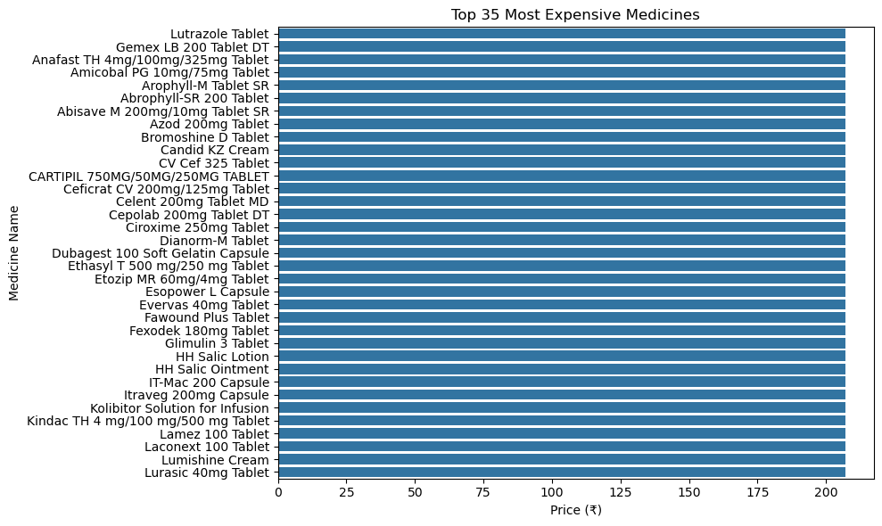
Code
plt.figure(figsize=(10,6))
sns.barplot(x='price(₹)', y='name', data=top10_high)
Observations
- Mostly injectable medicines.
- Critical-care medicines dominated the chart.
Example Medicines
- Arachitol 6L Injection
- ZI Fast Injection
- Azithral Injection
Conclusion
Specialty injections contribute heavily to pharmaceutical outliers.

8.2.7 Top 35 Least Expensive Medicines
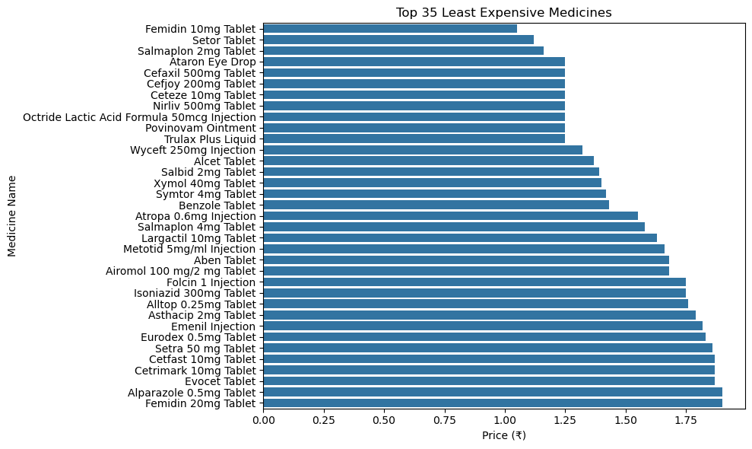
Code
plt.figure(figsize=(10,6))
sns.barplot(x='price(₹)', y='name', data=top10_low)
Observations
- Mostly generic tablets and syrups.
- Prices ranged between ₹1–₹15.
Conclusion
Generic medicines dominate the low-cost pharmaceutical segment.
Other bivariate analysis.
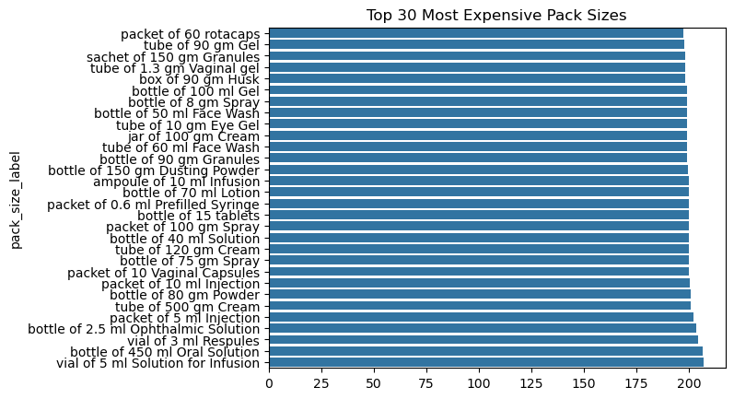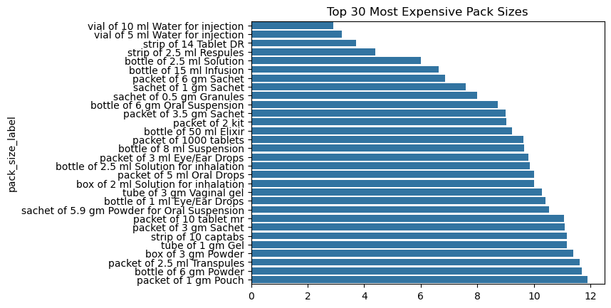

8.3 Multivariate Analysis
Multivariate analysis studies multiple variables together.

8.3.1 Violin Plot Analysis
Why Violin Plot?
Violin plots display:
- Distribution
- Density
- Spread
- Concentration
Code
sns.violinplot(x='form', y='price(₹)', data=combined_df)
Observations
Tablets
- Dense low-price cluster.
Syrups
- Stable pricing distribution.
Creams
- Moderate skew.
Suspensions
- Moderate spread.
Injections
- High density in upper price ranges.
- Strong outliers.
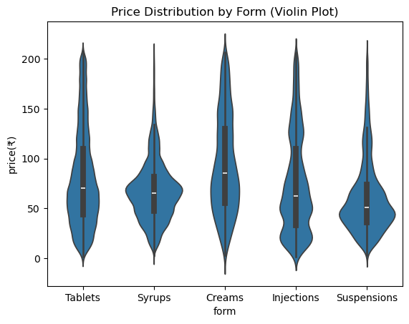
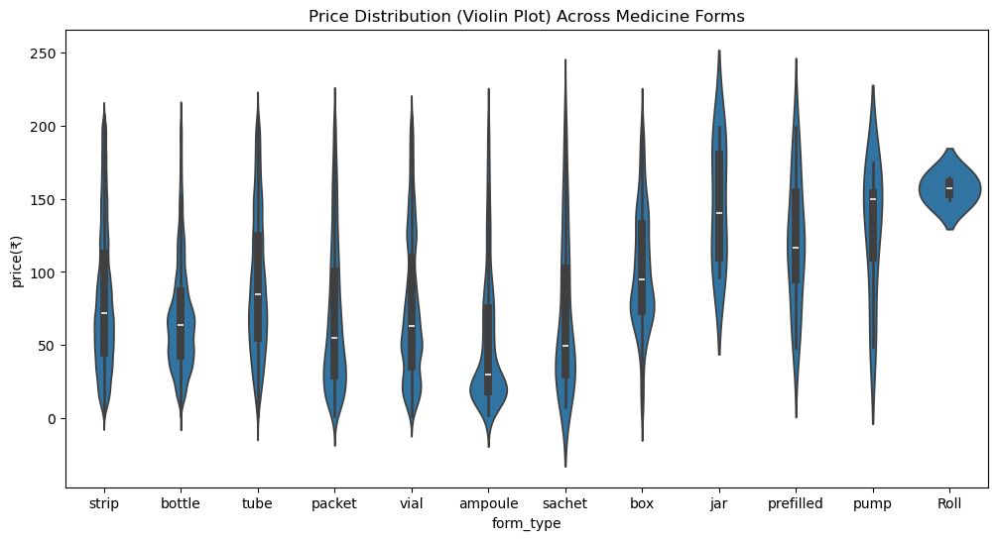
Conclusion
Violin plots clearly showed injections dominate premium pricing.
8.3.2 Heatmap and Correlation Analysis
Why Heatmap?
Heatmaps help identify correlations between features.
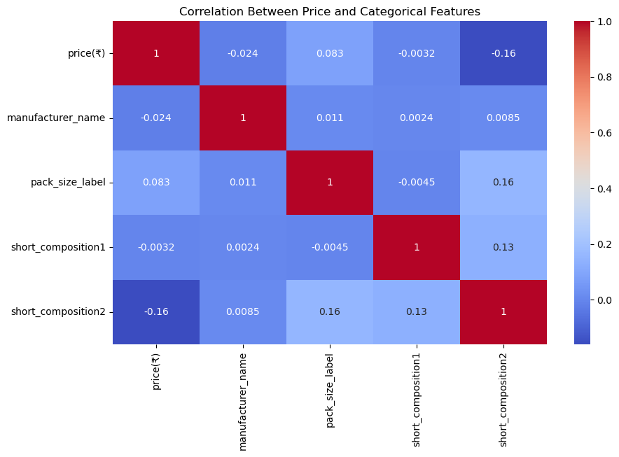
Observations
- Strength positively correlated with price.
- Form type and pack size affected pricing.
- Manufacturer and form combinations created price clusters.
Conclusion
Pharmaceutical pricing depends on multiple interacting variables.

9. Final Conclusions from Visualizations
Overall Price Distribution
- Medicine prices are highly right-skewed.
- Most medicines fall between ₹50–₹200.
- Few specialty medicines create extremely high outliers.

Form Type Analysis
Tablets
- Most common form.
- Lowest pricing.
- Highly stable.
Syrups
- Affordable and predictable pricing.
Creams
- Moderate pricing variation.
Suspensions
- Wider distribution than syrups.
Injections
- Highest average price.
- Strongest outliers.
- Premium therapeutic category.

Manufacturer-Level Insights
Premium Manufacturers
- Abbott
- Pfizer
- GSK
- Sun Pharma
- Sanofi
Generic Manufacturers
- Cipla
- Cadila
- Glenmark
- Mankind Pharma
- Zydus
Conclusion
Manufacturer specialization strongly affects pharmaceutical pricing.

Pack Size Insights
Highest Price Pack Sizes
- Injection vials
- Injectable packets
- Inhalers
Lowest Price Pack Sizes
- Tablet strips
- Generic packs
Conclusion
Packaging configuration heavily influences pricing.

Strength-Based Insights
- Higher dosage strengths generally had higher prices.
- Injectable formulations showed the highest price variation.

Final Summary
This project successfully analyzed pharmaceutical product data using data preprocessing, feature engineering, and exploratory data analysis techniques. Multiple visualizations including histograms, bar plots, pie charts, violin plots, and heatmaps were used to identify pharmaceutical pricing trends.
The analysis revealed that medicine form, manufacturer, pack size, and composition strength are the strongest factors influencing pharmaceutical pricing. Tablets dominate the affordable medicine market, while injections dominate the premium pricing segment.
The project provides valuable insights for:
- Healthcare analytics
- Pharmaceutical retailers
- Drug comparison systems
- Market segmentation
- Price optimization

10. Challenges Faced
- Handling missing values in composition columns.
- Managing extreme outliers.
- Extracting medicine forms from text.
- Feature engineering for strength extraction.
- Visualizing large categorical datasets.

11. Future Scope
Future improvements may include:
- Machine Learning price prediction models
- Drug recommendation systems
- Brand vs generic medicine comparison
- NLP-based composition analysis
- Clustering and segmentation models
- Time-series pharmaceutical price analysis

12. References
- OpenDataBay Pharmaceutical Dataset
- Python Documentation
- Pandas Documentation
- Matplotlib Documentation
- Seaborn Documentation
- Scikit-learn Documentation
- Jupyter Notebook Documentation

13. GitHub Repository
Project Notebook:
https://github.com/Tanuj-Manikanta-2007/-Pharmaceutical-Product-Data-Analysis/blob/main/G36_EDA_Pharmaceutical%20(1).ipynb

Prepared By:
Tanuj Pinninti
Project Title:
Pharmaceutical Product Data Analysis for Price Optimization & Drug Comparison

